

**Green University of Bangladesh**

**Department of Computer Science and Engineering (CSE)**

**Faculty of Sciences and Engineering**

**Semester: (Spring, Year:2022), B.Sc. in CSE (Day)**

**Course Title: Database System Lab**

**Course Code: CSE-210 Section:** **201_DJ**

**Lab Project Name: GUB Portal Management System**

**Student Details**

|  |  |  |
| --- | --- | --- |
| **Name** | | **ID** |
|  | Md. Abdul Kaiyum | 201002334 |

**Submission Date : 15/05/2022**

**Course Teacher’s Name : Mahmuda Rahman**

**[For Teachers use only: Don’t Write Anything inside this box]**

|  |
| --- |
| **Lab Project Status**  **Marks: ………………………………… Signature: .....................**  **Comments: .............................................. Date: ..............................** |

Table of Contents

Chapter 1 Introduction 3

1.1 Introduction 3

1.2 Design Goals/Objective 3

Chapter 2 Design/Development/Implementation of the Project 4

2.1 Procedure 4-5

2.3 Implementation 6-10

Chapter 3 Performance Evaluation 11

3.2 Results and Discussions 11-14

Chapter 4 Conclusion 15

4.1 Introduction 15

4.1 Practical Implications 15

4.2 Scope of Future Work 15

References 16

# Chapter 1 Introduction

## Introduction

A Portal Management System is also known as a Student & Teacher Information System . These

systems work to coordinate scheduling and communications between faculty regarding students.

GUB Portal Management System is to manage the details of profiles, Logins, database. It manages all the

information about Profiles, Student database. The Name of Project is GUB Portal Management System.

Where there will be a log in system. After successful login the user will get access to do their task

and all the task will be academic related.

## Design Goals/Objective

# GUB Portal Management System is a solution tool that is designed to track, maintain and manage

# all the data The project aims and objectives that will be achieved after completion of

this project isdiscussed in this subchapter. The aims and objectives are as follow:

# Try to make simple teachers corner.

# Help teacher to do their academic work easily.

# Try to do all the academic work in one place.

# Chapter 2

# Design/Development/Implementation of the Project

## Tools

To implement this project we have used these tools :

* + 1. **Netbeans**

I have used it to implement the Graphical user interface. We implemented several Jframes.

* + 1. **Xampp**

I have used it to implement the database .

**2.1. 3 GUI**

I have implemented the graphical user interphase in the java platform. I have used several Jframes in making the GUI’s.

I have several special methods while making the GUI’s-

* JOptionPane.showMessageDialog ()-to show messages .
* setVisible()- to open jframes.
* this.dispose()- to close jframes .
* setString(int, string)- to set String values in given index .
* EventQueue.invokeLater() - to save jframe updates.
* Class.forName() - to connect the gui with the database.

## Procedure

## We divided our procedure in some subsections. The procedure will be known after reading the subsections.

## 2.2.1 Getting Ready

In this phase we collected all the required resource required and set up our environment.

We used NetBeans and MySQL database and Java programming language to implement the

GUB Portal Management System.

**2.2.2 ER-Diagram**

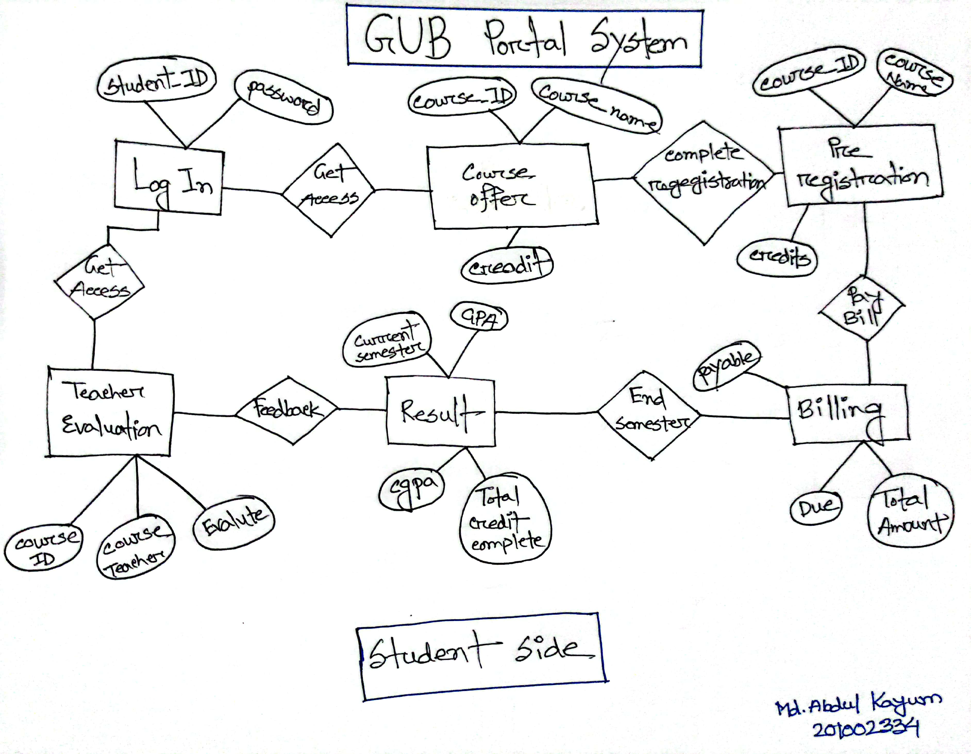

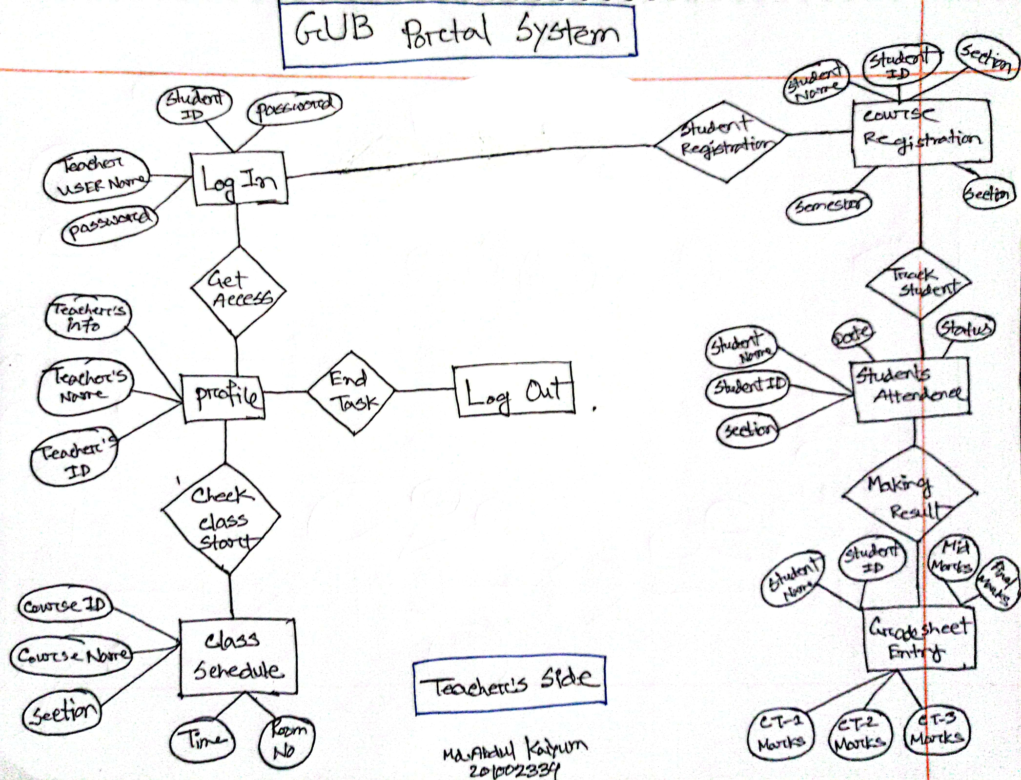

## Implementation

## In this following the procedure we had successfully implemented the GUB Portal

## Management System-

## 2.3.1 Sample GUI Code

## In this following the procedure we had successfully implemented the GUB Portal

## Management System-

## 

# 

Button1.setText("Submit");

jButton1.addActionListener(new java.awt.event.ActionListener() {

public void actionPerformed(java.awt.event.ActionEvent evt) {

jButton1ActionPerformed(evt);

}

});

getContentPane().add(jButton1, new org.netbeans.lib.awtextra.AbsoluteConstraints(340, 440, 100, 40));

jLabel1.setIcon(new

javax.swing.ImageIcon(getClass().getResource("/com/LMS/images/login_1.png"))); // NOI18N

jLabel1.setText("Submit");

jLabel1.setMaximumSize(new java.awt.Dimension(800, 600));

jLabel1.setMinimumSize(new java.awt.Dimension(800, 600));

getContentPane().add(jLabel1, new org.netbeans.lib.awtextra.AbsoluteConstraints(0, 0, 800, 600));

pack();

setLocationRelativeTo(null);

}// </editor-fold>

private void usernameActionPerformed(java.awt.event.ActionEvent evt) {

}

private void jButton1ActionPerformed(java.awt.event.ActionEvent evt) {

Database obj = new Database();

if(username.getText().length()==0) // Checking for empty field

JOptionPane.showMessageDialog(null, "Empty fields detected ! Please fill up all fields");

else if(password.getPassword().length==0) // Checking for empty field

JOptionPane.showMessageDialog(null, "Empty fields detected ! Please fill up all fields");

else{

String user = username.getText(); // Collecting the input

char[] pass = password.getPassword(); // Collecting the input

String pwd = String.copyValueOf(pass); // converting from array to string

if(validate_login(user,pwd)){

obj.setVisible(true);

this.dispose();

}

else

JOptionPane.showMessageDialog(null, "Incorrect Login Credentials");

}

}

8 | P a g e

Chapter 3

private boolean validate_login(String username,String password) {

try{

Class.forName("com.mysql.jdbc.Driver"); // MySQL database connection

Connection conn = DriverManager.getConnection("jdbc:mysql://localhost:3306/library_management_system","root","");

PreparedStatement pst = conn.prepareStatement("Select * from login where ID=? and pass=?");

pst.setString(1, username);

pst.setString(2, password);

ResultSet rs = pst.executeQuery();

if(rs.next())

return true;

else

return false;

}

catch(Exception e){

return false;

}

}

}

/**

* @param args the command line arguments

*/

public static void main(String args[]) {

java.awt.EventQueue.invokeLater(new Runnable() {

public void run() {

new Login().setVisible(true);

}

});

}

// Variables declaration - do not modify

private javax.swing.JButton jButton1;

private javax.swing.JLabel jLabel1;

private javax.swing.JPasswordField password;

private javax.swing.JTextField username;

// End of variables declaration

}

**2.3.2 Database**

To implement the database, I have used XAMPP. I have used several commands to create the database –

* Create table
* Insert Into
* Alter Table
* On delete and On Update
  + 1. **Database Codes :**

Here is the code for creating the Database-

Database: `gub_student_portal`

Table structure for table `registration`-

CREATE TABLE `registration` (

`student_id` varchar(30) NOT NULL,

`course_id` varchar(15) NOT NULL,

`course_name` varchar(30) NOT NULL,

`credit` varchar(10) NOT NULL,

`section` varchar(15) NOT NULL

)

# 

Table structure for table `result`-

CREATE TABLE `result` (

`student_id` varchar(15) NOT NULL,

`student_name` varchar(30) NOT NULL,

`Course` varchar(30) NOT NULL,

`ct1` varchar(15) NOT NULL,

`ct2` varchar(15) NOT NULL,

`ct3` varchar(15) NOT NULL,

`mid` varchar(15) NOT NULL,

`final` varchar(15) NOT NULL,

`assignment` varchar(15) NOT NULL,

`Total` varchar(15) DEFAULT NULL

)

Triggers `result`-

CREATE TRIGGER `Total_calculation` BEFORE INSERT ON `result` FOR EACH ROW BEGIN

set new.total=new.final+new.mid+new.assignment+((new.ct1+new.ct2+new.ct3)/3);

END

Table structure for table `schedule`-

CREATE TABLE `schedule` (

`course` varchar(20) NOT NULL,

`title` varchar(20) NOT NULL,

`section` varchar(10) NOT NULL,

`day` varchar(10) NOT NULL,

`time` varchar(20) NOT NULL,

`room_no` varchar(20) NOT NULL

)

Table structure for table `student_info`-

CREATE TABLE `student_info` (

`ID` varchar(15) NOT NULL,

`Name` varchar(30) NOT NULL,

`Department` varchar(15) NOT NULL,

`Phone` varchar(15) NOT NULL,

`Mail` varchar(30) NOT NULL

)

Table structure for table `student_login`-

CREATE TABLE `student_login` (

`id` varchar(15) NOT NULL,

`pass` varchar(30) NOT NULL

)

Dumping data for table `student_login`-

INSERT INTO `student_login` (`id`, `pass`) VALUES

('201002334', 'kaiyum334');

Table structure for table `teacher_evaluation`-

CREATE TABLE `teacher_evaluation` (

`T_id` varchar(255) NOT NULL,

`Teacher_name` varchar(30) NOT NULL,

`Course` varchar(15) NOT NULL,

`Marks` varchar(15) NOT NULL

)

Triggers `teacher_evaluation`-

CREATE TRIGGER `marks_to_teacher_info` BEFORE INSERT ON `teacher_evaluation` FOR EACH ROW BEGIN

update teacher_info set Marks=new.marks where T_id=new.T_id;

END

Table structure for table `teacher_info`-

CREATE TABLE `teacher_info` (

`T_id` varchar(255) NOT NULL,

`Name` varchar(30) NOT NULL,

`Course` varchar(15) NOT NULL,

`Phone` varchar(15) NOT NULL,

`Mail` varchar(30) NOT NULL,

`Marks` varchar(15) NOT NULL

)

Table structure for table `teacher_login`-

CREATE TABLE `teacher_login` (

`username` varchar(15) NOT NULL,

`password` varchar(15) NOT NULL,

`question` varchar(30) NOT NULL

)

Dumping data for table `teacher_login`-

INSERT INTO `teacher_login` (`username`, `password`, `question`) VALUES

('Mahmuda Rahman', '201002334', 'Pizza');

# Chapter 3 Performance Evaluation

## Results and Discussions

* + 1. **Results**

After completing all steps and objects we got the desired and satisfied result.

We were able to grasp the core requirement of our project and able to

Implement our project which is GUB Portal Management System.

**Database Tables:**

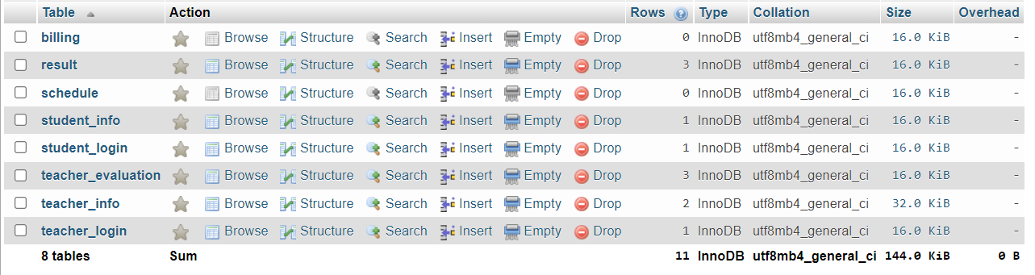

**Welcome frame:**

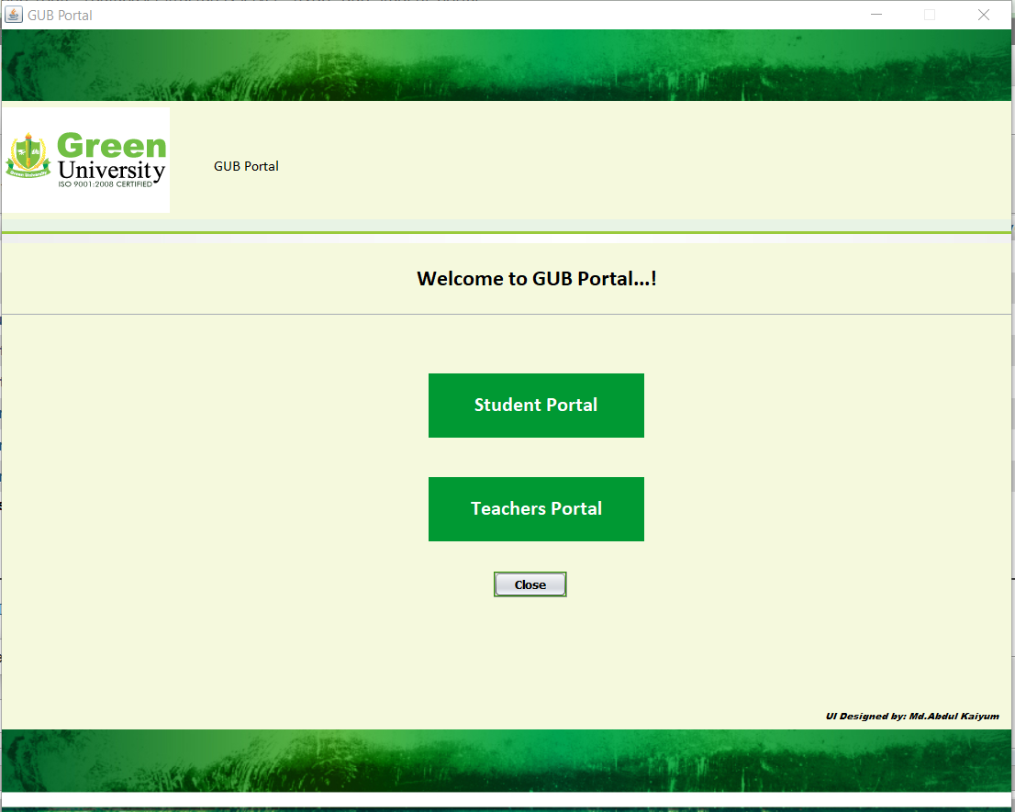

**Log In:**

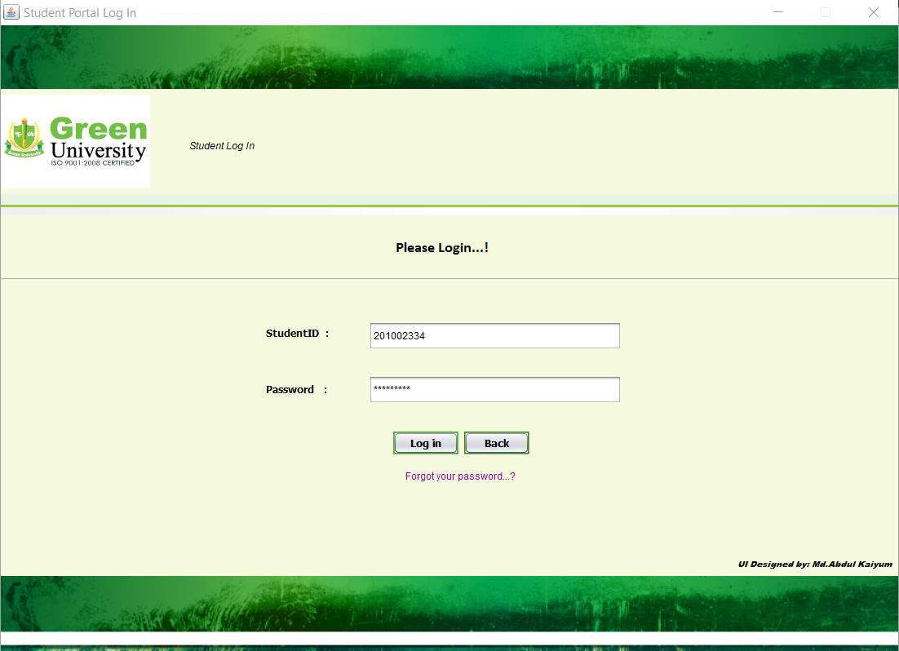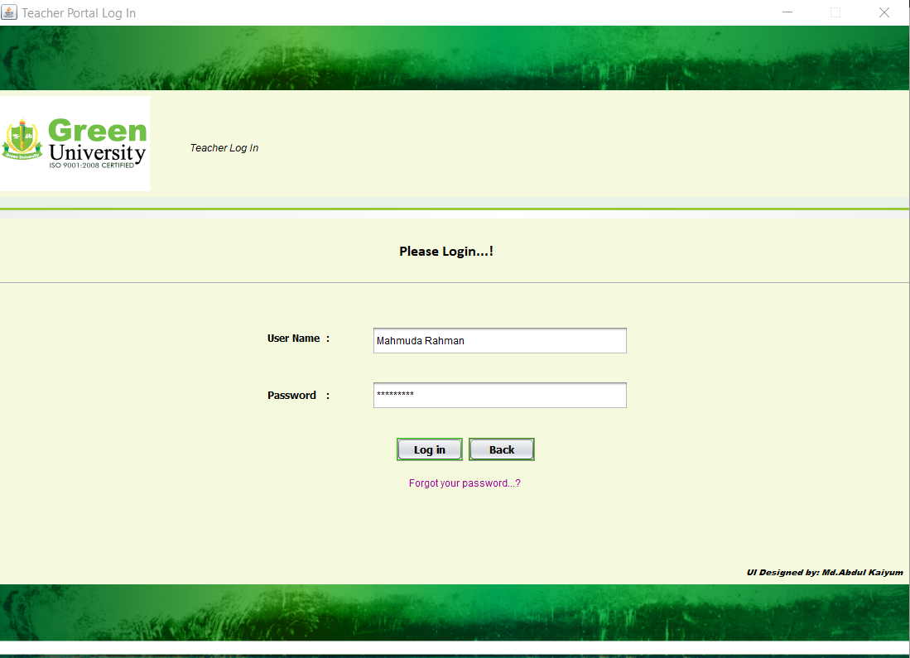







**Database:**

Password table-



Registration table-



Result table-



Student_Info table-



Teacher Evaluation table-



Teacher_Info table-



* + 1. **Analysis and Outcome**

Although we finished our project as we desired but there were a lot of obstacles

that we had to overcome during making the project. Some of the main obstacles

were:

a) We faced some problem in implementing part.

b) Also faced some problem when we run our code because lagging.

c) When user put some value the program work very slowly.

# Chapter 4 Conclusion

## Introduction

I basically decided to make GUB Portal management System project because it helps

both Students and Teachers. This project also helps the institutional workload. In this project

i have tried to add more features. But there is a problem i implemented this project only for

a single user but implementing multi user which is little bit critical for me. Mainly I focus

that, I can make a portal system for student and teacher both can login in this portal system.

## Practical Implications

GUB Portal management System is basically use for institutional work load. We can also

call as portal System. Here,

* Can be use in any Educational Institute.
* Both Student and Teacher can use.
* All options are in one place.
* Updatable according to our need.
* Simple & easy to use.

## Scope of Future Work

This project has a lot of potentiality.

1. By using this project an institution can have better utilization of time &

resources.

2. This project certainly will enhance productivity.

3. This project will improve inter-relations between Departments.

4. So given the facts, if the logic behind this project is on point, then this project

will run perfectly and as a result any institution would definitely want to buy this

project.

So, it is clear that this project will help us personally and professionally.

# References

1. Head First Java by “Kathy Hussain & Bert Bates”
2. Java Programming by “A N M Bojlur Rahman”
3. https:// javatpoint.com//
4. https://stackoverflow.com/
5. https://www. https://www.w3schools.com/sql/
6. <https://www.youtube.com>